Hands-on Exercise No. 1  DigiSkills 3.0 Batch-03  Data Analytics and Business Intelligence | Total Marks: 10  Due Date: 14/05/2026

Hands-on Exercise No. 2
Data Analytics & Business Intelligence
DigiSkills 3.0 Batch-03

Name: | Zain Latif
Date: | 14-05-2026
Course: | Data Analytics & Business Intelligence

Task1: Remove all empty rows from the dataset using Power Query Editor. (2-Marks)
the dataset contains several completely empty rows with no values in any column. These rows will cause errors in calculations and reports
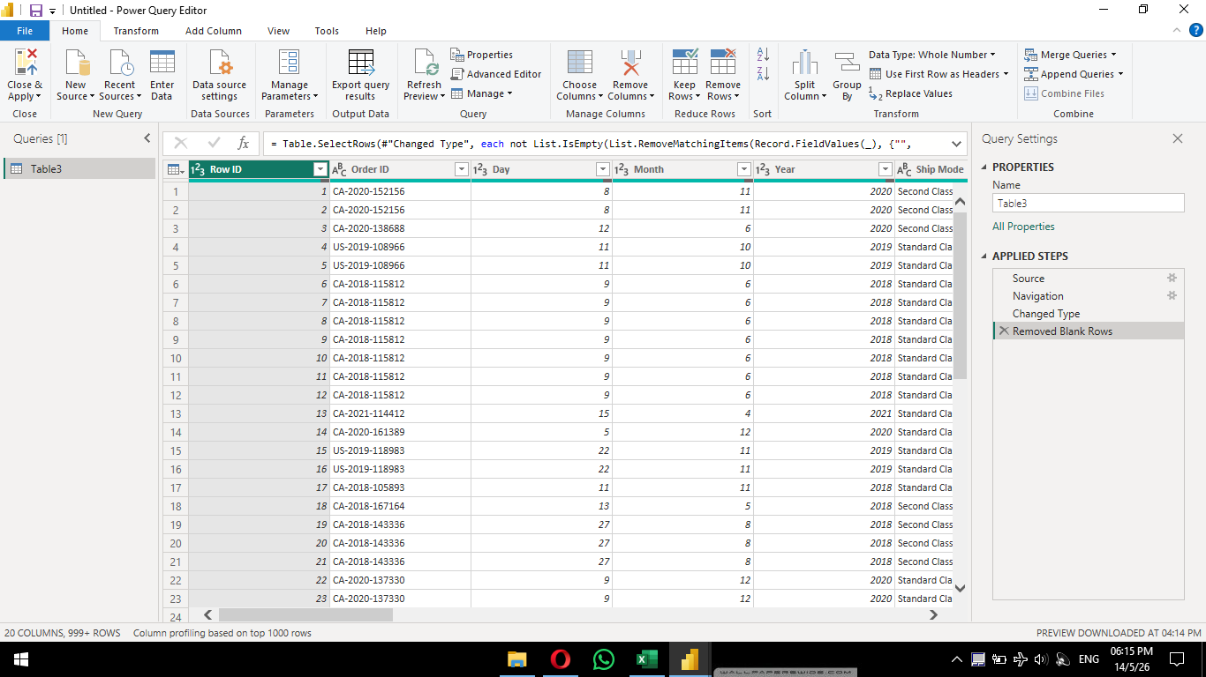

Task2: Identify and remove duplicate rows so that each transaction appears only once.
find that some transactions have been accidentally entered twice in the dataset (identical values across all columns
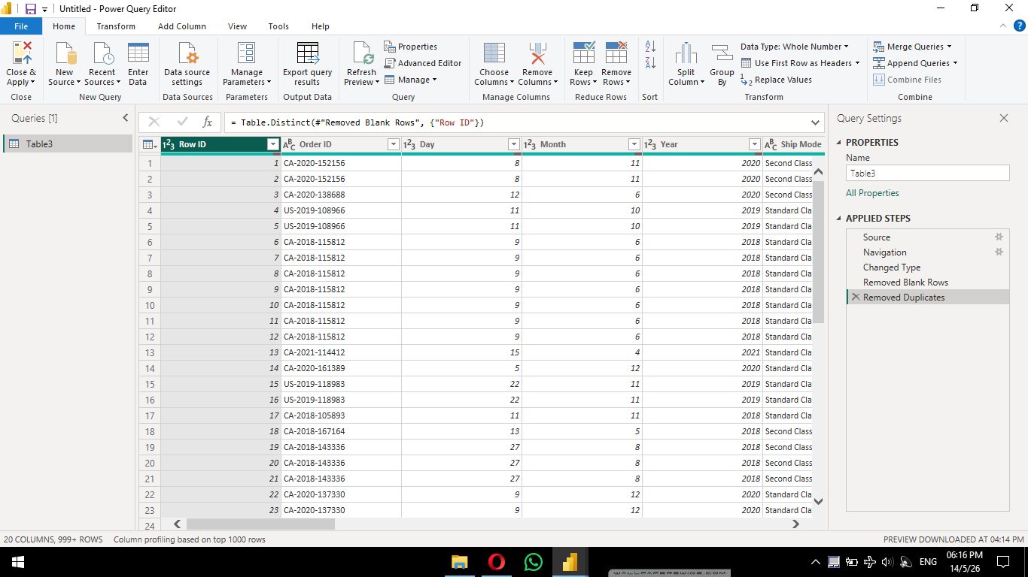

Task3: Convert all customer names to Proper Case using the options in Power Query Editor
The Customer Name column contains names in inconsistent formats. For example: mike williams (all lowercase
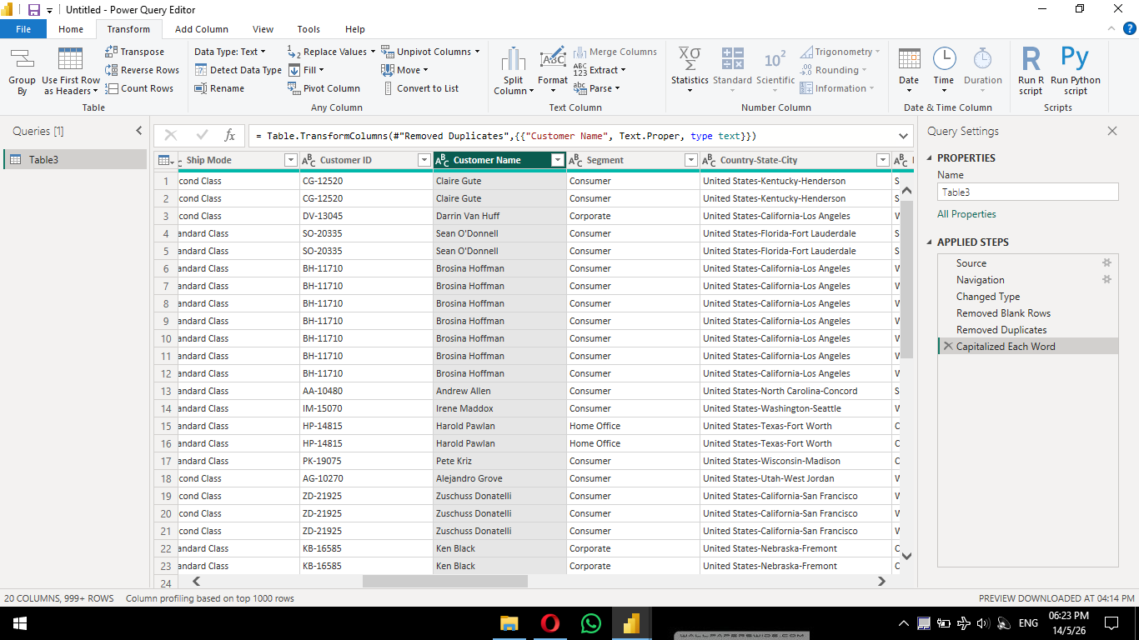

Task 4: Merge the Day, Month, and Year columns into a single column named Order Date. Use a hyphen - as the separator between values.
dataset has three separate columns for order date
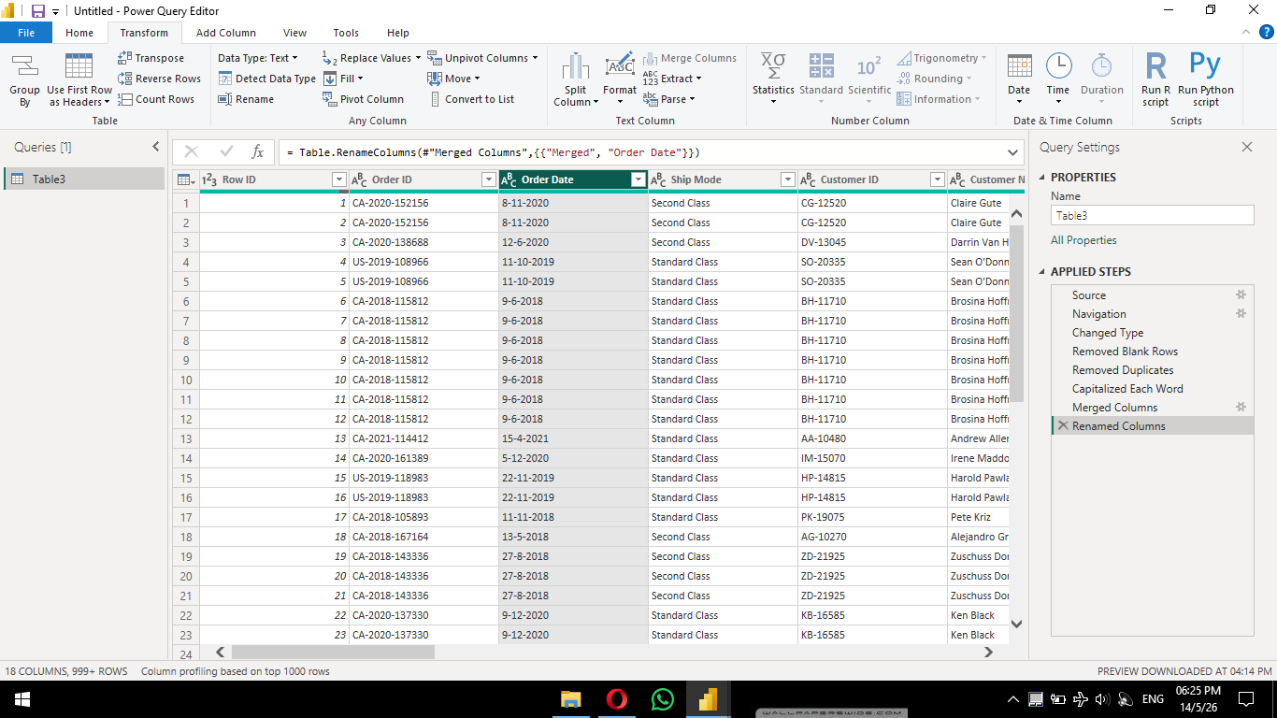

Task 5: Split the column into three separate columns named: Country, State, and City.
The dataset contains a column named Country-State-City that combines Country, State, and City information using hyphens as separators. For example: United States-Kentucky-Henderson
